Comparative Analysis of OS-Level Access Control and Pre-Recognition Authentication Mechanisms for Preventing USB-Based Data Theft

First Author¹, Second Author², Third Author³ (10 pt)
Institute of Computing Studies, Mabalacat City College, Mabalacat City, Pampanga 2010 (9 pt)

ABSTRACT (10 PT)
- INTRODUCTION

In today’s digital environment, information security has become an important concern as computers and electronic devices are increasingly used to store, process, and transfer sensitive information. The growth of digital technologies has made information easier to access and share, but it has also created new opportunities for unauthorized access and data theft. Among the different methods used to transfer information, removable storage and USB-based devices remain widely used because they are convenient, portable, and compatible with many computer systems. However, the same features that make USB devices useful can also introduce security vulnerabilities.

Despite their usefulness, USB-based devices can create significant security risks through their ability to communicate directly with computer systems. Their connectivity can provide opportunities for data theft, malware deployment, and unauthorized system access. As organizations and individuals increasingly depend on digital systems to store and process sensitive information, protecting computers from unauthorized USB activity has become an important cybersecurity concern.
The National Cyber Security Centre identifies several risks associated with removable media and external interfaces, including unauthorized data exfiltration, malicious device impersonation, and attacks involving direct memory access [1]. To address these threats, operating systems and organizations commonly implement technical and administrative security controls such as Group Policy, device restrictions, user permissions, and antivirus software. These mechanisms are designed to restrict unauthorized devices and activities and help protect sensitive information from potential security threats.
Nevertheless, OS-level controls may not fully protect systems from USB devices that imitate trusted Human Interface Devices (HID). Nicho and Sabry demonstrated that a malicious USB HID could bypass multiple security layers, including operating-system controls, Windows Defender, Group Policy restrictions, and antivirus protection [2]. This demonstrates a potential limitation of relying exclusively on security mechanisms that operate after a USB device has already been recognized by the operating system.
Related studies have therefore explored approaches that can identify or evaluate USB devices before they are fully trusted by the host system. Wang and Hsu proposed a USB intrusion prevention framework that uses USB device descriptors and behavior-based checks to identify and block potentially malicious peripherals [3]. Similarly, Koffi et al. investigated USB power-consumption characteristics as a means of detecting malicious peripherals before they are fully trusted by the host [4]. These studies support the importance of examining security mechanisms that operate earlier in the USB device recognition process.
In this context, this study focuses on the comparative analysis of OS-level access control and pre-recognition authentication mechanisms for preventing USB-based data theft. A Python-based measurement tool will be used to collect and evaluate experimental data, such as USB detection and access-control performance. The study will examine how these approaches differ in controlling USB device access and preventing unauthorized data transfer. Through an experimental comparison, the study aims to assess the security capabilities and limitations of each approach and provide information that may contribute to improving protection against USB-based threats.

1.1. Background of the study

USB-based devices are widely used for data storage, peripheral communication and system interaction; however, their connectivity also creates opportunities for data theft, malware deployment and unauthorized system access. The National Cyber Security Centre identifies several risks associated with removable media, including unauthorized data exfiltration, malicious device impersonation, and attacks involving direct memory access [1]. In response, operating systems and organizations use technical and administrative controls such as Group Policy, Device restrictions, and antivirus software.

Nevertheless, these controls may not fully protect systems from USB devices that imitate trusted Human Interface Devices. Nicho and Sabry demonstrated that a malicious USB HID could bypass multiple security layers, including OS controls, Windows Defender, Group Policy restrictions, and antivirus protection [2]. These findings indicate a limitation in relying exclusively on OS-level access control and support the study's investigation of an experimental comparison of these security approaches that verify a USB device before normal access is granted.

1.2. Statement of the problem

USB-based attacks can threaten the confidentiality and security of information stored on computers. Traditional operating system access controls may restrict certain USB devices, but malicious peripherals can potentially exploit the implicit trust given to connected devices.

Specifically, the study seeks to examine the following problems:

- How effective are OS-level access controls in preventing unauthorized USB device access and data theft?
- How resistant are the security mechanisms to controlled HID-based access attempts?
- How effective is pre-recognition authentication measurement in identifying or blocking unauthorized USB devices before OS-level recognition?
- How accurately does each mechanism identify authorized and unauthorized USB devices?
- Is there a significant difference between OS-level access control and pre-recognition authentication mechanisms in terms of:
a. Data Exfiltration Block Success Rate;
b. Unauthorized Access Success Rate;
c. Policy Enforcement Latency;
d. Authentication/Authorization Time;
e. USB Device Recognition Accuracy;
f. Enforcement Consistency;
g. Audit Logging Completeness; and
h. System Usability Impact?

1.3. Objectives of the Study

The general objectives of this study are to experimentally compare the effectiveness of OS-level access control and pre-recognition authentication mechanisms in preventing unauthorized USB-based data theft and malicious peripheral activity.

The Study specifically aims to:

- Measure the percentage of unauthorized USB data-transfer attempts successfully blocked by each security mechanism.
- Determine the rate at which controlled HID-based access attempts bypass the implemented security controls
- Measure the time required for the system to recognize a USB device and apply the appropriate security policy
- Measure the time required to authenticate a USB device before access is granted
- Determine the consistency of each security mechanism across repeated trials
- Compare the performance of Windows GPO and Linux USBGuard, and the selected pre-recognition authentication mechanism under controlled conditions

1.4. Research Questions

This research seeks to answer the following questions:

- What is the data exfiltration block success rate of each USB security mechanism?
- What is the HID payload bypass rate of each security?
- What is the policy enforcement and authorization latency of each mechanism?
- What is the unauthorized access success rate under each experimental condition?
- How complete are the audit logs produced by each security mechanism?
- How consistent is each mechanism in enforcing its configured security policy across repeated trials?
- Is there a significant difference in the effectiveness of the tested USB security mechanisms in preventing unauthorized data access?
1.5. Research Hypotheses

Null Hypothesis
There is no significant difference in the effectiveness of OS-level access control and pre-recognition authentication mechanisms in preventing unauthorized USB-based data theft under the same controlled experimental conditions.

Alternative Hypothesis
There is a significant difference in the effectiveness of OS-level access control and pre-recognition authentication mechanisms in preventing unauthorized USB-based data theft under the same controlled experimental conditions.

1.6. Significance of the study

This study may be beneficial to the following:

Users. This study might contribute to enhanced users’ understanding of USB-related security threats, access control, authentication, and data protection mechanisms. Additionally, the study might provide practical insights into testing and assessing different USB security control measures using a Python-based measurement tool. Moreover, the study might raise awareness among users about potentially unauthorized and/or malicious USB devices and promote the importance of access-control and authentication mechanisms in securing data against unauthorized access and transfer.
Organizations and Institutions. Schools, businesses, and other organizations can apply the results as guidelines for creating or updating policies on removable media and USB device security. The study may help organizations better understand different approaches to preventing unauthorized USB access and protecting sensitive data
System Administrators. The results can offer system administrators hints regarding how effective OS-level USB access control mechanisms such as Windows Group Policy (GPO) and Linux USBGuard can be, and what limitations they might have, in conjunction with the selected pre-recognition authentication mechanism. The outcome can be used as a reference when considering USB security policies and controls.
Future Researchers. This study may serve as a reference for future researchers conducting studies on USB security, access control, authentication, removable-media protection, and malicious peripheral detection. The experimental methodology and measurement criteria may also provide a basis for further research involving other operating systems, authentication mechanisms, USB devices, or security-testing conditions.

1.7. Scope and Limitations

Scope:
Target Systems: Testing is focused on the effectiveness of the deployed Linux USBGuard pre-recognition authentication daemons and the native GPOs available for Windows within the virtualized environments

Payload Testing: With the use of the controlled USB mass storage device, protection against data exfiltration, simulating data exfiltration attempts, and the emulated HID simulating keystroke injection.

Evaluation Metrics: Rate of success in data exfiltration; rate of success in policy enforcement as measured by the latency of policy enforcement; rate of success in unauthorized data exfiltration; completeness of audit logs; consistency of enforcement; USB Device Recognition Accuracy; usability impact to the system

Environment: All tests are performed within a fully isolated hypervisor-based laboratory using dummy datasets.

Limitations:
Hardware Virtualization: Results may show slight timing differences when performed over hypervisor USB passthrough compared to bare hardware execution

Scope of Attack Vectors: Only USB mass storage exfiltration and HID keystroke injection are used.

Selection of Platforms: Only Windows GPO and Linux USBGuard are used.

1.8. Review Related Literature

Removable media, particularly USB-based devices, pose a critical security threat to modern computing environments due to their potential to facilitate data theft, data loss, and malware deployment. According to the UK National Cyber Security Centre, peripheral devices and external interfaces presents significant security risks, including unauthorized data exfiltration via removable mass storage, malicious keystroke injection via interface masquerading (e.g., BadUSB), and direct system memory compromise through Direct Memory Access (DMA) exploits. To mitigate these threats, major operating systems implement built-in technical controls, such as Mobile Device Management (MDM) configuration profiles, Group Policy Object (GPO) class-whitelisting, and kernel-level IOMMU memory protections [1]. However, empirical findings by Nicho and Sabry demonstrate that standard OS-level and administrative controls failed to mitigate hardware mimicking USB devices, specifically Arduino-based Human Interface (HID). It can bypass up to four distinct OS-level security layers, including OS Firewalls and Group Policy Objects(GPO)[2].

USB-based attacks, including data theft, exploit the inherent trust hosts place in connected peripherals. Wang and Hsu demonstrate the importance of OS-level USB Access control is critical by proposing the USBIPS framework, which enforces descriptor-based allowlisting and behavior-driven checks to block malicious USB peripherals to prevent unauthorized data exfiltration [3]. USB-based attacks are hard to detect when malicious peripherals mimic legitimate hardware. Koffi et al. demonstrate that analyzing USB power-consumption characteristics can detect malicious peripherals before they are fully trusted by the host [4], supporting the need for stronger pre-recognition controls before allowing USB devices to interact with the system.

1.9. Experimental Framework

The framework illustrates the relationship between the USB Security mechanisms, the experimental testing process, and the measured outcomes of the study. The independent variable consists of the USB

security mechanisms being evaluated, including the unprotected baseline, Windows Group Policy Object (GPO) and Linux USBGuard.

The Experimental testing process subjects each configuration to two standardized testing scenarios:

Scenario A (Mass Storage Exfiltration): Uses standard USB flash drive loaded with dummy datasets to attempt unauthorized read and write file operations across the host operation system.

Scenario B (HID Keystroke Injection): Uses an ATmega32U4 USB programmed as an emulated USB HID device. To ensure testing is completely safe and non-destructive, the board executes a benign Proof-of-Concept (PoC) payload that opens a basic text editor (Notepad) and types a static verification string to confirm whether the keystroke inputs are accepted by the host operating system

Measurement Instrument: A custom Python-based measurement program automatically monitors hardware insertion events, logs policy enforcement latencies, verifies filesystem mount states, scans system audit logs, and samples CPU/RAM utilization across every trial iteration.
.

Independent Variables

Unprotected Baseline
Windows Group
Policy Object
(GPO)
Linux USBGuard

Scenario A: Mass Storage Exfiltration
Standard USB Flash Drive
Scenario B: HID keystroke Injection
ATmega32U4 USB
Python-Based Measurement & Log Collection tool

* Data Exfiltration Block Success Rate (%) * Audit Logging Completeness (%)
* Policy Enforcement Latency (ms) * Enforcement Consistency (%)
* Authentication/Authorization Time (ms) * USB Device Recognition Accuracy (%)
* Unauthorized Access success rate (%) * System Usability Impact
Experimental Testing Process
Dependent Variables

1.10. Definition of Terms
Data Exfiltration: An unauthorized copy/transfer of data from the internal system to an external storage device.

Human Interface Device (HID) Keystroke Injection: A mechanism where a programmed USB device emulates a standard keyboard interface to execute a malicious command rapidly.

OS-Level Access Control: Software policies enforced within the operating system, such as Group Policy Objects (GPO) of Windows, that manage device permissions and file access rights.

Pre-Recognition Authentication: Security mechanisms, such as the USBGuard daemon of Linux, that intercept and authorize USB devices at the system daemon before the operating system grant host access or binds the hardware drivers.

Policy Enforcement Latency: A time measurement of the duration from the connection of a USB peripheral to the host system access control decision.

Audit Logging Completeness: Percentage and detail level of recorded event identifiers, such as Product ID and timestamp, captured by the system security during the access event.

USB Device Recognition Accuracy: Percentage of the experimental trials in which the security mechanisms correctly identify the device attributes and enforce the right configuration policy.

- METHODOLOGY (TECHNICAL METHODOLOGY if TECHNICAL RESEARCH) (10 PT)
This study will employ a quantitative experimental comparative research design to evaluate and compare the effectiveness of operating-system-level USB access control and USB device authorization mechanisms in preventing unauthorized USB-based data access and controlled HID-based activity.

Three experimental conditions will be evaluated: (1) an unprotected baseline, (2) Windows Group Policy Object (GPO), and (3) Linux USBGuard. The unprotected baseline will represent the normal behavior of the operating system without an additional USB security policy. Windows GPO will represent an operating-system-level access-control mechanism for removable storage, while USBGuard will represent a USB device authorization mechanism that evaluates connected USB devices according to configured rules.

A Python-based measurement and data-collection program will be developed and used as a common experimental instrument across the tested operating systems. The Python program will not serve as the security mechanism and will not determine whether a USB device is authorized or blocked. Instead, it will collect experimental observations, record timestamps and test outcomes where technically available, obtain relevant system information and logs, and organize the collected data for analysis.

Using the same measurement program and standardized experimental procedure across the test environments is intended to reduce differences caused by manual measurement. The security decision will remain under the control of Windows GPO or USBGuard.

The experiment will evaluate the security mechanisms using controlled USB mass-storage and HID test scenarios. The primary dependent variables will include Data Exfiltration Block Success Rate, HID Payload Bypass Rate, Unauthorized Access Success Rate, Policy Enforcement Latency, Authorization Latency, USB Device Recognition/Authorization Accuracy, Audit Logging Completeness, Enforcement Consistency and System Usability impact.

All experiments will be conducted in an isolated VMware-based laboratory using controlled USB devices.

Table 1. The performance of ...
Variable | Speed (rpm) | Power (kW)
x | 10 | 8.6
y | 15 | 12.4
z | 20 | 15.3
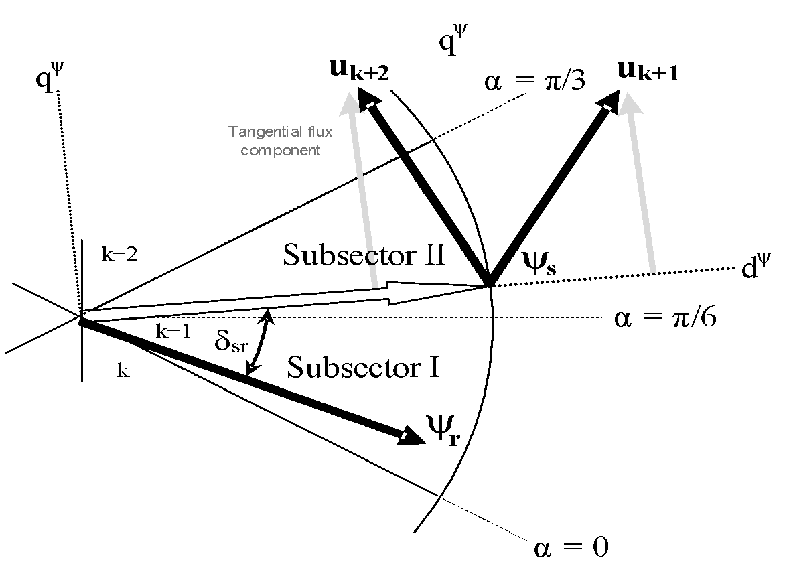

Figure 1. Effects of selecting different switching under dynamic condition
2.1. Experimental Research Design

2.2. Research Environment
The experiment will be conducted in an isolated virtualized laboratory consisting of a host computer, vmware, Windows virtual machine, Linux virtual machine, USB test devices, and a Python-based measurement program.

The virtual machines will use equivalent hardware configurations as far as supported by the selected hypervisor. Clean virtual-machine snapshots will be created before formal testing to allow the environment to be restored between experimental trials
2.3. Network and System Architecture

2.4. Variables
Independent Variable
The independent variable is the type of security control mechanism implemented on the virtual machine. The study will compare the following conditions:
- Windows Group Policy (GPO) Removable Storage Access Control;
- Linux USBGuard Device Authorization; and
- Unprotected Baseline, where no additional USB access-control mechanism is applied.
Dependent Variables
The dependent variables are the measurable outcomes used to evaluate the effectiveness and reliability of each security control mechanism:
- Data Exfiltration Block Success Rate (%) — the percentage of unauthorized data-transfer attempts that are successfully prevented by the security mechanism;
- Policy Enforcement Latency (milliseconds) — the time required for the system to recognize the USB device and apply the appropriate access-control decision;
- Authentication/Authorization on Time (milliseconds) — the time required to authenticate or authorize the USB device before access is granted;
- Unauthorized access success rate (%) — the percentage of USB access attempts that successfully reach the protected test data;
- Audit Logging Completeness (%) — the extent to which each access attempt is properly recorded, including available information such as the USB device's Vendor ID, Product ID, and timestamp; and
- Enforcement Consistency (%) — the percentage of repeated experimental trials in which the security mechanism produces the expected access-control decision under the same conditions.
- USB Device recognition accuracy (%) — the percentage of test trials in which the system correctly identifies and applies the intended policy to the USB device
- System Usability Impact (%) — the observed delay or disruption experienced during legitimate USB access.
Control Variables
To ensure that the comparison is fair and that differences in the results are primarily associated with the security mechanism being tested, the following factors will be kept consistent:
- Hypervisor platform and version;
- Virtual machine hardware specifications, including allocated CPU, memory, and storage;
- Virtual USB controller configuration;
- USB hardware endpoints and test payload files;
- Operating conditions and testing procedures;
- Number of experimental trial iterations; and
- Test dataset and file sizes used during each trial.
2.5. Materials and Tools
2.6. Experimental Procedure
2.7. Data Collection
2.8. Data Analysis
2.9. Validity and Reliability
2.10. Ethical and Security Considerations

- RESULTS AND DISCUSSION (10 PT)
In this section, it is explained the results of research and at the same time is given the comprehensive discussion. Results can be presented in figures, graphs, tables and others that make the reader understand easily. The discussion can be made in several sub-chapters.

3.1. Sub section 1
xx

3.2. Sub section 2
yy

- CONCLUSION (10 PT)
Provide a statement that what is expected, as stated in the "Introduction" chapter can ultimately result in "Results and Discussion" chapter, so there is compatibility. Moreover, it can also be added the prospect of the development of research results and application prospects of further studies into the next (based on result and discussion).

REFERENCES (10 PT)
The main references are international journals and proceedings. All references should be to the most pertinent, up-to-date sources and the minimum of references are 15. References are written in IEEE style. Please use a consistent format for references – see examples below (9 pt):
- National Cyber Security Centre, “Using peripherals securely,” in Device Security Guidance, Jun. 29, 2021. [Online].Available:https://www.ncsc.gov.uk/collection/device-security-guidance/policies-and-settings/using-peripherals-securely
- M. Nicho and I. Sabry, "Bypassing multiple security layers using malicious USB human interface device," in Proceedings of the 9th International Conference on Information Systems Security and Privacy (ICISSP 2023), Lisbon, Portugal, 2023, pp. 501–508.
- C.-Y. Wang and F.-H. Hsu, “USBIPS Framework: Protecting Hosts from Malicious USB Peripherals,” Comput. Stand. Interfaces, vol. 95, p. 104040, Jan. 2026,
- K. A. Koffi, C. Smiliotopoulos, C. Kolias, and G. Kambourakis, “To (US)Be or Not to (US)Be: Discovering Malicious USB Peripherals through Neural Network-Driven Power Analysis,” Electronics, vol. 13, no. 11, p. 2117, 2024,

